Contents

Chapter 3 Theoretical framework

3.1 Operational characteristics of propulsion components

3.2 Input power

3.3 Factors affecting the propulsion system

3.3.1 Internal factors

3.3.2 Eternal factors

3.4 Power loss in the gearbox

3.4.1 Power loss in the gear

3.4.2 Power loss in the bearing

3.4.3 Power loss in shaft

3.4.4 Power loss in propeller

3.5 Simulate the resistance caused by wind

3.6 Simulation of the resistance caused by wave

3.7 Simulation of the resistance caused by ocean current

3.8 Define the output power of a ship's propulsion system

# Chapter 3 Theoretical framework

## 3.1 Operational characteristics of propulsion components

In this paper, aiming to reveal the details of energy conversion through the solar boat propulsion system so that researchers can build a calculation chain to simulate the propulsion system and optimize the propulsion system with higher efficiency. The solar boat propulsion system which consists by the electric motor (as prime mover), the gearbox and the shaft (as transmission system) and the propeller (as propulsor). Furthermore, since the thrust delivered by the propeller is to overcome the ship resistance, which strongly depends upon the external forces that impose to the boat. So the wind and wave have been considered. (Shi1 & Grimmelius, 2009)

## 3.2 Input power

The energy of the propulsion system comes from the electric motor powered by the solar panel.

## 3.3 Factors affecting the propulsion system

In the process of energy transmission, the output power of the motor cannot be completely converted into the output power of the propeller due to the influence of some factors. And due to the influence of other external factors, the propulsion power output by the propeller needs to overcome a series of resistance to become the force to accelerate the ship.

To go from the solar panel battery to the ship moving, the total energy conversion efficiency could be divided into four parts, the hull efficiency; the propeller efficiency, the transmission efficiency and the engine efficiency. Since our boundary does not include the hull and motor. Researchers decide to use a fixed value to represent the hull resistance and use the output power from the motor are used as the input of the system. (Shi1 & Grimmelius, 2009)

Motor

Input Power

Propulsion System

Output Propulsion Force

Internal Power Loss

External Power Loss

### 3.3.1 Internal factors

Transmission efficiency and propeller efficiency are the main part of the internal energy loss factors. The researchers figure out which component mainly cause the energy loss of these two parts. The main energy loss happened in the gearbox and propellers.

### 3.3.2 Eternal factors

The external energy loss mainly comes from wind and waves and the resistance of the hull. The researchers set the hull's own resistance to a fixed value, and input the wind intensity value and the wave intensity value related to the Dutch sea area into the calculation chain to simulate the propulsion system of the solar ship.

## 3.4 Power loss in the gearbox

Power loss in a gearbox consists of gear, bearing, seal and auxiliary losses. (Klaus Michaelis, 2011). Gear and bearing losses can be separated into no-load losses, which occur even without power transmission. Except the working conditions and the air gap in the gearbox, no-load losses mainly relevant to lubricant viscosity and density while the immersion depth of the components dipping into the lubricant also contribute to the no-load losses.

Load-losses depend on transmitted load, coefficient of friction and sliding velocity in the contact areas of the components. The power loss in gear is typically dominant in the nominal power transmission situation. For part load and high speed, high no-load losses dominate the total losses. For optimizing the whole operating range of a gearbox and simulating the transmission flow by calculation chain. In the following topics, the major factors that lead to gearbox power losses mainly consider the bearings ; gears and shaft.

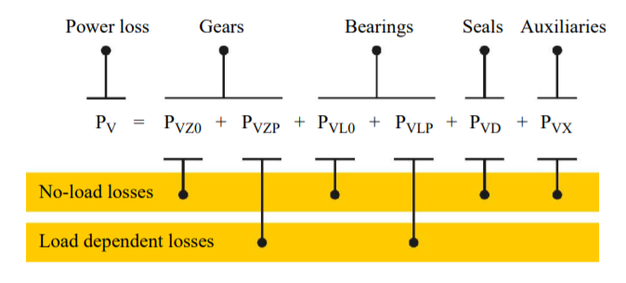

Figure Composition of transmission power loss

### 3.4.1 Power loss in the gear

#### 3.4.1.1 No-load gear losses

The no-load gear losses ensue from immersion depth in sump lubricated gearboxes; lubricant viscosity and operating conditions. Since the operating conditions are uncontrollable, the immersion depth in lubricant and lubricant viscosity will be mainly concerned.

For immersion depth in sump lubricated gearbox. The immersion depth of the gear will affect the meshing of the gear and cause the loss of energy. Therefore, at different immersion depths, the gear loss in this part is different. (Lin Zou, 2018)

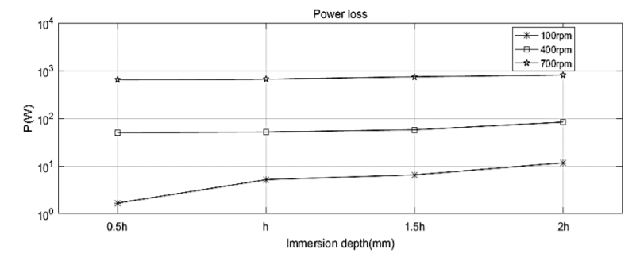

Figure The effect of the immersion depth on power loss at three different rotational

In the figure we can see that high immersion depth may lead to higher energy loss, which is caused by lubricant resistance. But in order to prevent rust, reduce friction, heat dissipation and other disadvantages, we cannot blindly reduce the lubricant immersion depth. Researchers hope to find a suitable lubricant immersion depth range, which can achieve less energy loss and satisfy its function. (Lauer, 2013)

For lubricant viscosity. The energy loss due to the lubricant mainly depends on the viscosity of the lubricant. High-viscosity lubricants will increase churning loss. The viscosity of the lubricant decreases with increasing temperature. When the load is immense, the lubricant with a high viscosity is suitable, and when the speed is high, the lubricant with a low viscosity is suitable. Researchers hope to find suitable lubricants for solar boats. (k.Michaelis&B.-R.Hohn)

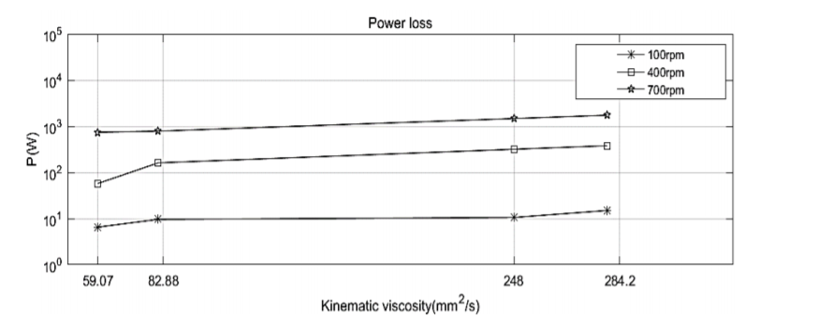

Figure The effect of the viscosity on the power loss at three different rotational speed.

In the figure, we can also derive conclusion that the energy loss of high-speed gears is greater than that of loss-speed gears.

#### 3.4.1.2 Load dependent losses

The load gear losses PVZP in the mesh while power is transmitted follow the basic Coulomb law: (Klaus Michaelis, 2011)

with:

load gear losses (kW).

friction force (kN).

relative velocity (m/s).

Regarding the calculation of and will be defined in the final report. From the formula, we can infer that the load energy loss is related to the roughness of the gear and the relative speed of the gear contact surface. Although lubricant will cause no-load energy loss, it can also reduce load energy loss.

### 3.4.2 Power loss in the bearing

The energy loss in the bearing can also be divided into no-load loss and load dependent loss. The no-load loss in the bearing mainly cause by the type and size of the bearing, the arrangement of the bearing, the viscosity and supply of the lubricant. (Klaus Michaelis, 2011) There is a graph show the no-load power loss difference between bearing type.

The radial bearing has the lowest no-load loss. Rolling bearings with low taper are suitable for no-load bearing arrangements. When considering the cross load, axial preloading is required, which greatly increases the no-load energy loss of the tapered roller.

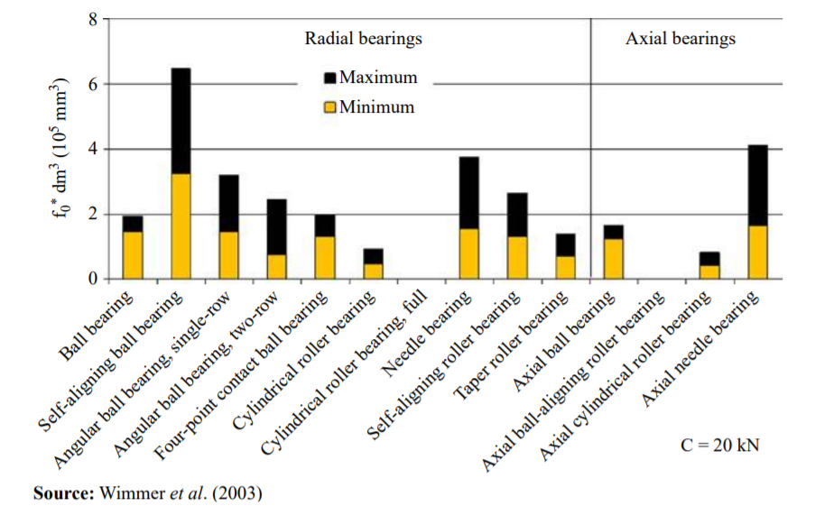

Figure Influence of bearing type on no-load losses

When it comes to load-dependent losses. The load dependent losses depended on bearing type and size, load and sliding conditions in the bearing and on the lubricant type. Figure 5 shows load-dependent losses of the bearing with same load capacity C =20kg.

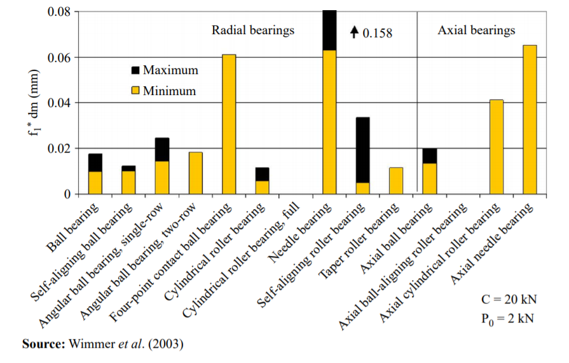

Figure Influence of bearing type on load losses

Cylindrical rollers have the lowest axial power loss. Under the same load, tapered rollers have small energy losses due to their smaller diameter.

### 3.4.3 Power loss in shaft

Since power is a function of speed and torque. The speed will not be affected by the length of the shaft, but the torque will. The length of the shaft had an effect on torsional (twisting) stiffness. The longer it is, the less stiff. If the torque on the shaft is varying a lot, then those changes in torque are damped by the deflection of the shaft. If the shaft is under constant torque, the torque loss is almost zero, but in real life, the load is not constant. So the length of the shaft will affect the energy loss.

Friction on the shaft can also cause energy loss, so lubricants are needed to help reduce losses caused by friction.

### 3.4.4 Power loss in propeller

The propeller is used to generate thrust to overcome the ship resistance. Normally, an open water diagram is used to determine the propeller operational behavior. Because realistic waters and open waters are rarely the same. Energy loss occurs when the power of the propeller in open water is converted into actual propeller power. (Shi1 & Grimmelius, 2009)

## 3.5 Simulate the resistance caused by wind

Wind is considered as external energy resistance. Since the wind is not fixed and varies from day to day, the researchers found the average wind value of the Dutch sea detected by the testing station. Use this mean as the input value of the calculation chain.

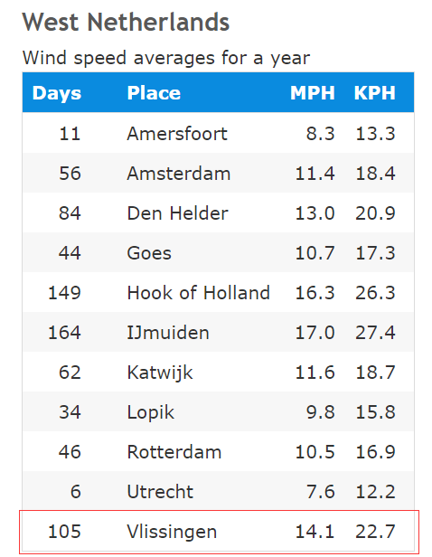

Figure West Netherlands wind speed averages for a year (Annual Average Wind Speeds in the Netherlands, 2010)

The chart shows the average wind speed for a year in miles per hour (MPH) and kilometers per hour (KPH). All the numbers here are based on weather data collected from 1981 to 2010.

## 3.6 Simulation of the resistance caused by wave

Wave is considered as external energy resistance. Since Vlissingen does not have a wave detection point, the researchers decided to use data near Honte Sloehaven as the wave input. (Waterinfo-Wave, 2020)

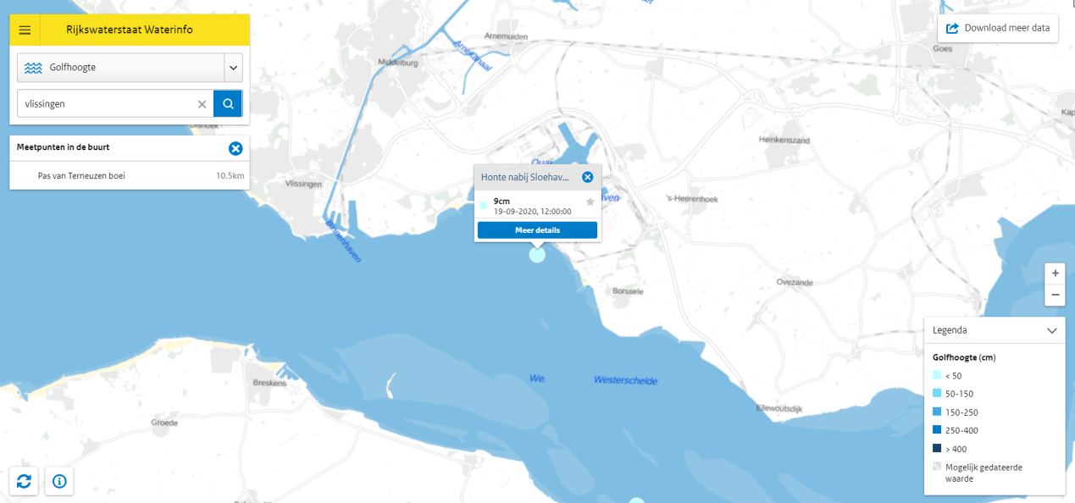

Figure Wave height detection near Vlissingen

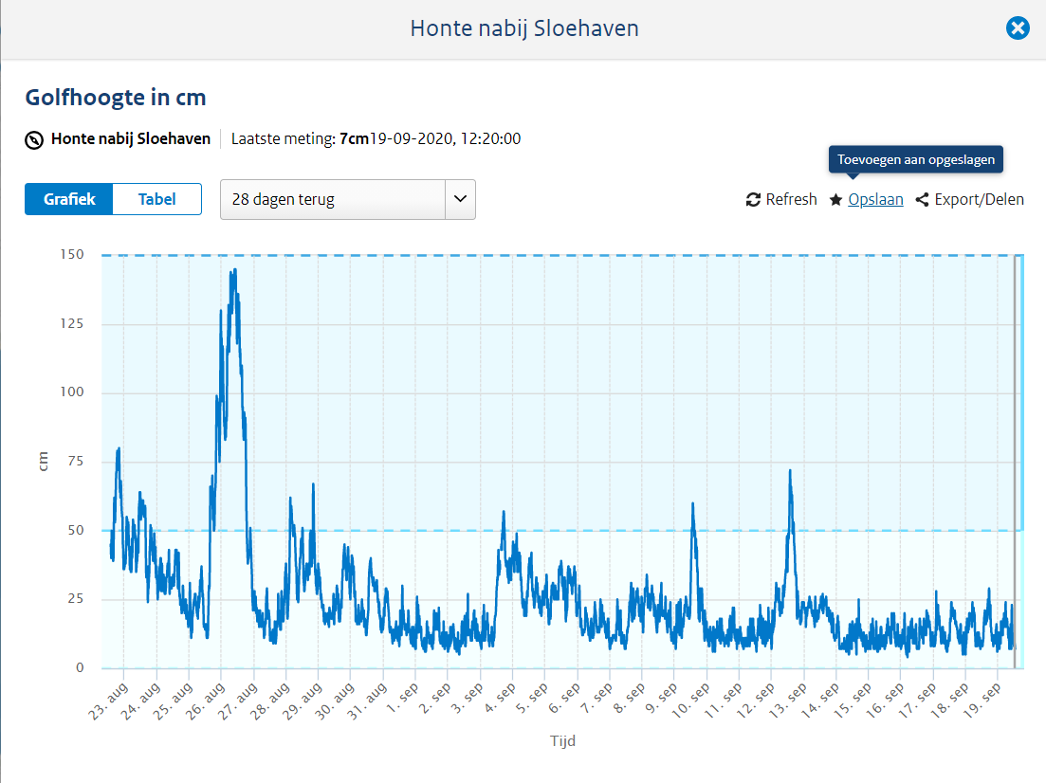

Figure Wave height data for the past month

It can be seen from the table that the wave data fluctuates greatly, but the data is concentrated around 10cm.

## 3.7 Simulation of the resistance caused by ocean current

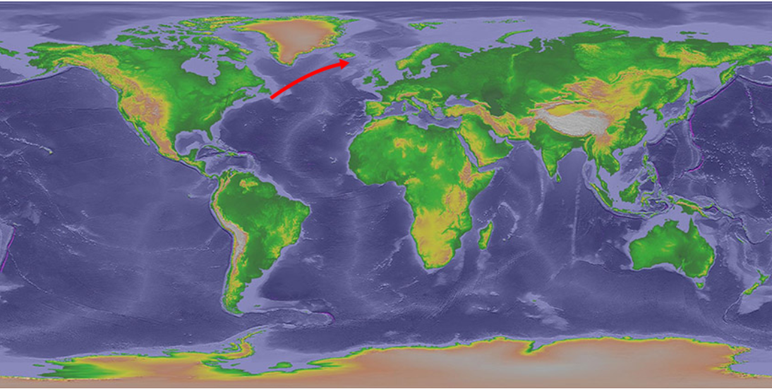

Figure 9 North Atlantic current (Major Ocean Currents, noun date)

The ocean current surrounding the Netherlands is the North Atlantic Warm Current, the most powerful warm current in the northern Atlantic Ocean, and is a continuation of the Gulf Stream. The North Atlantic warm current runs from southwest to northeast. (North Atlantic Current, Noun date)The direction of the ocean current will affect the navigation of the ship. Although the solar boat is driven by a propeller with less dependent on ocean currents and winds, but all ships can benefit from making good use of ocean currents. According to research, ocean currents in offshore areas can be ignored. (Willemsen, 2019)

3.8 Define the output power of a ship's propulsion system

When studying the final output power of the propulsion system, the output power can be estimated by calculating the displacement of the propeller and velocity pf the water. Or set a force sensor behind the propeller to detect the thrust generated by the propeller.

According to the formula. We need to get the thrust generated by the propeller and the speed of the water, and we can calculate the power output by the propeller.

Or you can measure the volume of water (V) that the propeller discharge in the rated time (t) and the distance (S) of the boat movement. Use the volume of water multiplied the density of the water () to calculate the mass of discharged water so as to calculate the power output of the propeller.

Annual Average Wind Speeds in the Netherlands. (2010). source: Current Results weather and science facts: https://www.currentresults.com/Weather/Netherlands/wind-speed-annual.php

k.Michaelis&B.-R.Hohn. (无日期). Influence of Lubricants on Power Loss of Cylindrical Gears. source: Taylor and Francis Online: https://www.tandfonline.com/doi/abs/10.1080/10402009408983279

Klaus Michaelis, B.-R. H. (2011). *Influence factors on gearbox power loss.* Retrieved from https://mediatum.ub.tum.de/doc/1323611/file.pdf

LauerA.Dennis. (2013). Gear Lubrication. source: Encyclopedia of Tribology: https://link.springer.com/referenceworkentry/10.1007%2F978-0-387-92897-5_19#howtocite

Lin Zou, M. D. (2018, 6). *Numerical Simulation of the Churning Power.* Retrieved from Wuhan University of Technology: https://pdfs.semanticscholar.org/ef43/b4a9f1f400e9fefe3b8d3c2f5841b9e99c18.pdf

*Major Ocean Currents*. (noun date). Retrieved from national weather servies: https://www.weather.gov/jetstream/currents_max

North Atlantic Current. (Noun date). source: wikipedia: https://en.wikipedia.org/wiki/North_Atlantic_Current#:~:text=The%20NAC%20flows%20northward%20east,crosses%20the%20Mid%2DAtlantic%20Ridge.

Shi1, W., & Grimmelius, D. S. (2009). *Analysis of energy conversion in ship*. Retrieved from https://www.witpress.com/Secure/elibrary/papers/ESUS09/ESUS09041FU1.pdf

Waterinfo-Wave. (2020/9/19). source: waterinfo: https://waterinfo.rws.nl

WillemsenDiederik. (2019/April/7). Currents. source: Currents & Navigation: https://www.sailingissues.com/navcourse8.html